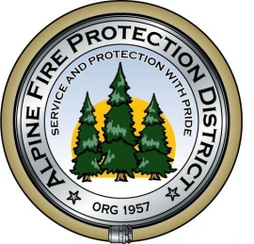

**ALPINE FIRE PROTECTION DISTRICT**

**FIRE PREVENTION POLICY MANUAL**

Fire Rated and Listed Materials for the installation of water storage tanks as per NFPA 22.

FIRE CHIEF APPROVAL EFFECTIVE DATE

STANDARD

REVISED

10,000 gallon tanks Listed OS&Y Valve Nut and Bolt kits Companion Flanges

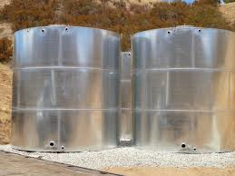 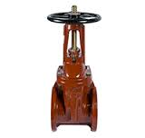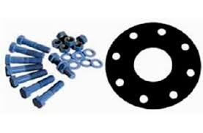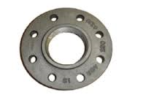

Listed Underground Fittings Rated Underground materials Rated above ground materials Listed Spools

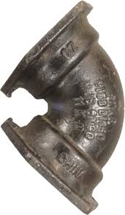 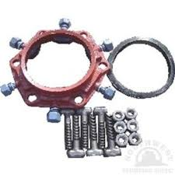 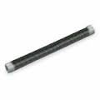 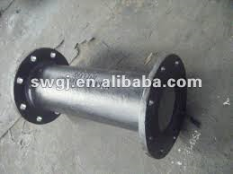

Rated underground PVC pipe Listed fire hydrant rated bushings Approved exterior Paint.

